**Final Project:**

**Netflix Database**

**Names of Participants**:

Daaron McFarling Bao-Tran Phan Shrinath Rao Shurong Tian Adam Uribe Jerry Zeng

**Class**: CS4347.0U1 || **Professor**: Dr. Cankaya || **Term**: Summer 2018

**Table of Contents**

Deliverable I………………………………………………………………………..…..…… 2 - 6

Introduction………………………………………………………………………………2

Delegation of Tasks………………………………………………………………………2

Research on Similar Pre-Existing Databases…………………………..…….....…… 3 - 5

EER Diagram v.1 (external file)………………………………………………………… 6

Schema Diagram v.1(external file)………………………………………………....…… 6

SQL Code Statements (external file)……………….…………………………………… 6

Deliverable II…………………………………………………………………....…………… 7 - 8

Delegation of Tasks…………………………………………………………………....… 7

EER Diagram v.2 (external file)…………………………………………………….…… 7

Schema Diagram v.2(external file)………………………………………………....……..7

Changes made since v.1………………………………………………………………..7 - 8

Dependency Diagram (external file) ………………………………………………..……8

CREATE VIEW Statements(external file)…………………………………………..……8

GUI Video(external file).....................................................................................................9

Database User Interface……………………………………………………………....9 - 11

**Netflix Database: Deliverable I**

***Introduction***

Movies and TV have always been a major topic of discussion among millenials. Previously, big movie rental companies, such as RedBox and Blockbuster, have played major roles in the sense of socialization, however, the use of technology and the internet has become more widespread among the developed world. At this point, we have progressed to a point where streaming media is a more viable solution than playing media through physical disks.

Netflix is a video streaming service that has become very popular among millennials because of its usability and its extensive library of various movies and TV shows.Since we all use Netflix, our team thought it would be interesting to try and develop a database to understand the potential workings behind the scenes.

If our team implements this database, it will be mainly for our education and to help us understand the processes of creating a functioning database. By having the necessary information in a database needed for a user to watch videos in a simplistic way, once a GUI is created, a person would have a practical video streaming application.

***Delegation of Tasks for Deliverable I***

|  |  |
| --- | --- |
| **Member Name** | **Primary Role** |
| Daaron McFarling | Comparison to Similar Works |
| Bao-Tran Phan | Documentation Editing |
| Shurong Tian | EER and Schema diagrams |
| Shrinath Rao | Editing and Implementation |
| Adam Uribe | Implementation of Database in MS SQL |
| Jerry Zeng | Diagram creation |

***Research on Similar Pre-Existing Databases***

Our team did some research to see what aspects we could potentially utilize in our own Netflix database. Other than looking at other Netflix databases, we checked examples for entities that would provide similar services to Netflix, such as iTunes and DVD Rentals. Our

**1. Sample DVD Rental Database** *by PostgreSQL*

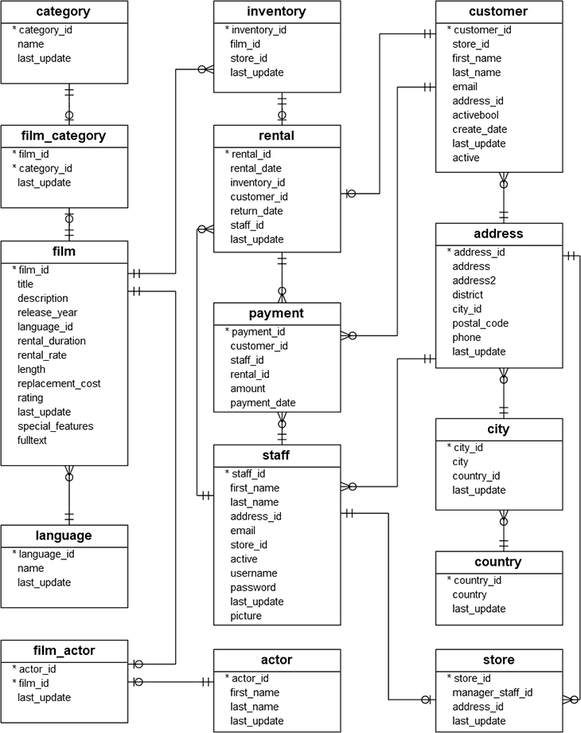

**[1] About this Database**: This sample database found on SQL tutorial website. It is designed as a DVD rental service, which Netflix used to be. Many attributes we had not originally considered when creating our own database, such as language, actor and director IDs, and many other different ways to keep track of content besides a large database of *all* films [1]. While this database accounts for stores ours does not since we are considering a video streaming service.

**2. Popular UI Volume 2- iTunes** *by Grapecity*

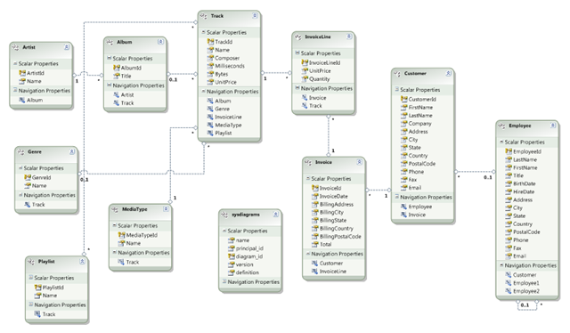

**[2] About This Database:** Another similarly designed database would be one designed for another media platform for music, such as iTunes. This database model introduced us to idea for multiple platforms that could be running the same application of Netflix. For example, we could have users that have Netflix running on various devices, such as their smart TVs, their Phones, tablets, consoles, PCs, etc... [2] While this database accounts for devices ours doesn't’ since ours focuses more on Netflix’s capability to recommend and track statistics.

**3. OLTP Netflix Database** *by Rona Charlene Lao*

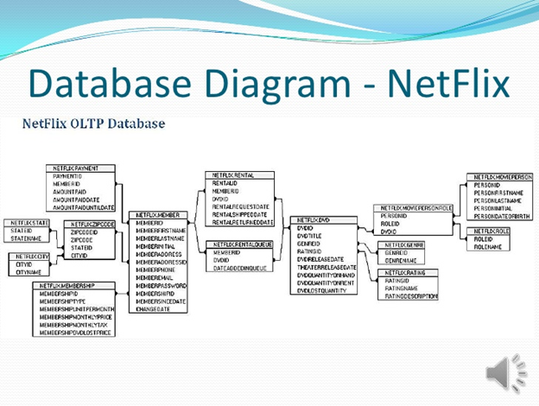

**[3] About This Database:** This database keeps track of online transaction processing. It has a large number of attributes to keep track of payment information, which we plan to implement something similar in our own database to keep track of a customer’s payment information [3]. This database is quite similar to our own since we too will want to keep track of the user’s payment info.

***Sources***

[1] Postgresqltutorial.com. (2018). PostgreSQL Sample Database. [online] Available at:

https://bit.ly/2dnqtnr [Accessed 25 Jun. 2018].

[2] B, C. (2018). Popular UI Volume 2 – iTunes. [online] GrapeCity. Available at:

https://bit.ly/2tIyyfN [Accessed 28 Jun. 2018].

[3] Lao, R. (2018). Ronalao termpresent. [online] Slideshare.net. Available at:

https://bit.ly/2KoN72z [Accessed 27 Jun. 2018].

***EER Diagram v. 1***

See attached file “v1_EER+Schema Diagrams.pdf” in deliverable 1 folder.

To get a better view for both diagrams, zoom in to at least 125%.

***Schema Diagram***

To get a better view, please see the attached file “v1_EER+Schema Diagrams.pdf” in deliverable 1 folder and zoom in to at least 125%.

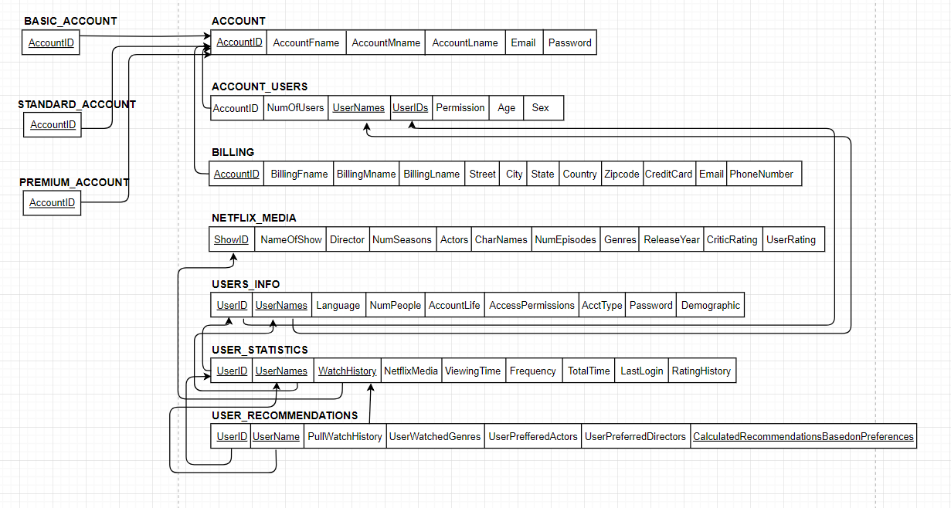

<https://drive.google.com/file/d/1XMl9-Hld8NtNq-RA3TRe-1E9-FEn9Xcq/view?usp=sharing>

***SQL Code with Insert Statements***

See attached file, “v1_Netflix.sql” in deliverable 1 folder.

**Netflix Database: Deliverable II**

***Delegation of Tasks for Deliverable II***

|  |  |
| --- | --- |
| **Member Name** | **Primary Role** |
| Daaron McFarling | Documentation, Diagram Updates |
| Bao-Tran Phan | Documentation, Diagram Creation and Updates |
| Shurong Tian | Back-end GUI |
| Shrinath Rao | Front-end GUI |
| Adam Uribe | Create view statement, Updated SQL Code,  Updated Schema Diagram |
| Jerry Zeng | Diagram Updates |

***Schema Diagram v.2***

See attached “*Schema Diagram v2.png*” in deliverable 2 folder.

***EER Diagram v.2***

See attached “*EERv2.png*” in deliverable 2 folder.

To get a better view of the diagram, zoom in to at least 125%.

***Changes made since v.1:***

While creating the dependency diagram for our database, we noticed to some redundant and/or unnecessary attributes, such as for the following information:

* Removed TotalTime since it is essentially the same thing as ViewingTime from UserStatistics
* Removed Username since it was redundant to userID information. Since we changed our scope to more back-end statistics, there is no use for the database user to use userName.
* Removed password from UserInfo since each user does not have a unique password. (Every user under the same main account will have one password.)
* Removed Username from User_REcommendations since recommendations will be linked to a specific userID anyway.

After redefining a few definitions, which caused some changes in PKs and FKs, such as for the following:

* Username is no longer a PK in Account_Users since users may have the same username but their associated UserID would still be unique to a specific user.

We also shifted some attributes around, realizing that they fit better elsewhere, such as the following:

* NumPeople went from Account_Users to Account since the the numbers of users using the account is more applicable to users as a whole and not for every individual user.

***Dependency Diagram***

The diagram was created using draw.io: <https://goo.gl/oj6wLU>

To see the full diagram, click the link or see the external file “*dependencyDiagram.png*” in deliverable 2 folder.

***CREATE VIEW Statement***

To see Create View statement, see “NetflixView.sql” in deliverable 2 folder.

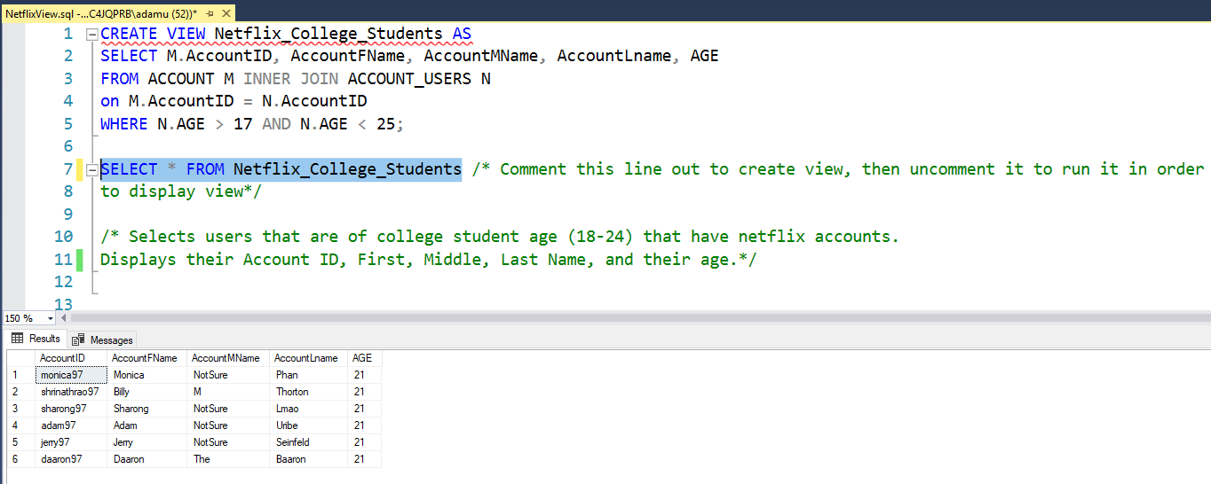

Updated SQL Code can be found in Deliverable 2 folder in file “v2_Netflix.sql”

***Database User Interface***

Our team used Java 1.8 to create the user interface.

**See video titled “GUI Video.mp4” in Deliverable 2 folder to see GUI in action. All screenshots below are taken from the video.**

(All screenshots can be found in Deliverable 2 folder if they are too small to see in the document as shown below)

***Modify Operation on Account***

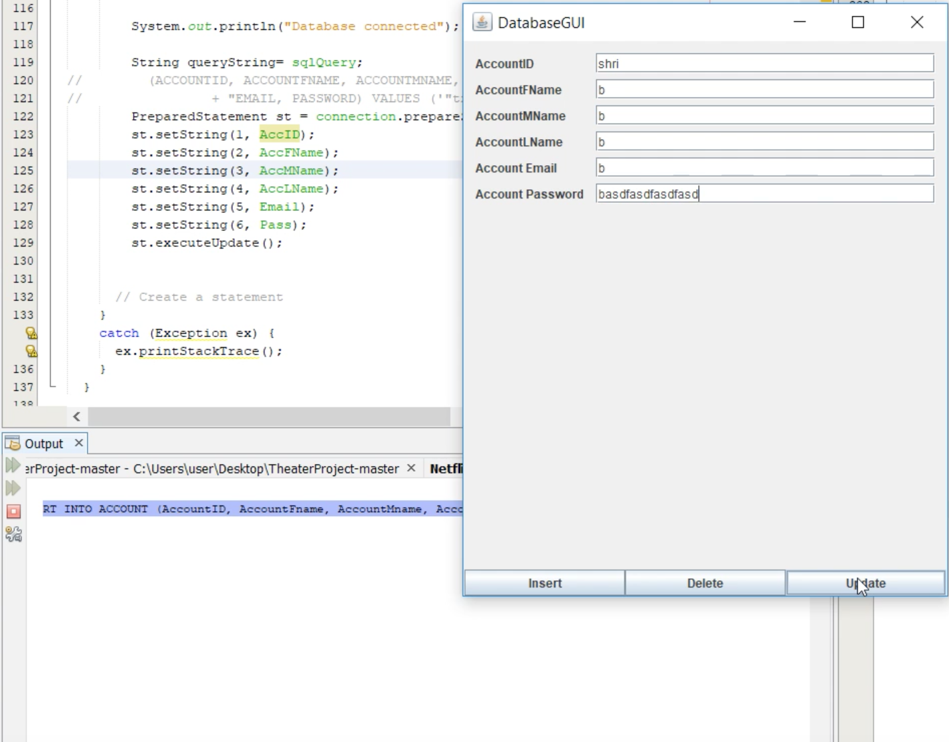

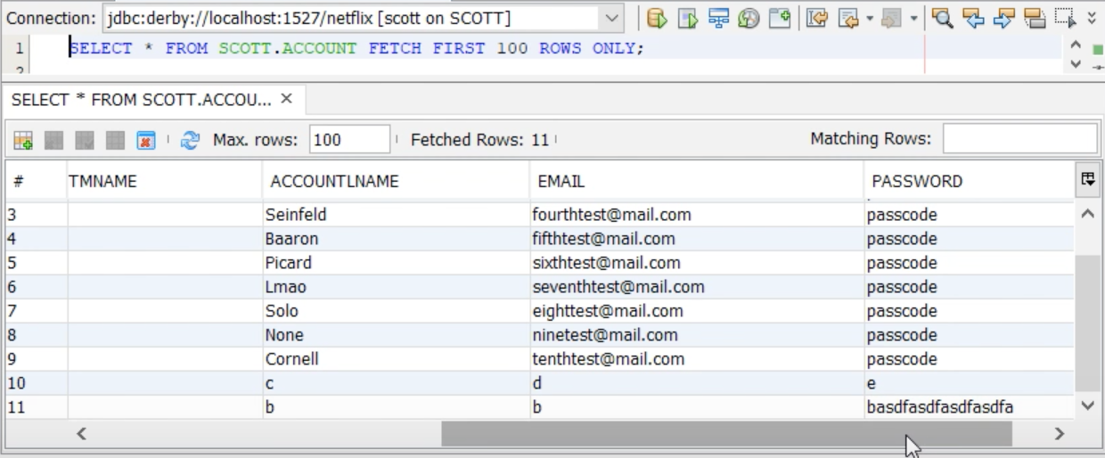

***Insert Operation on Account***

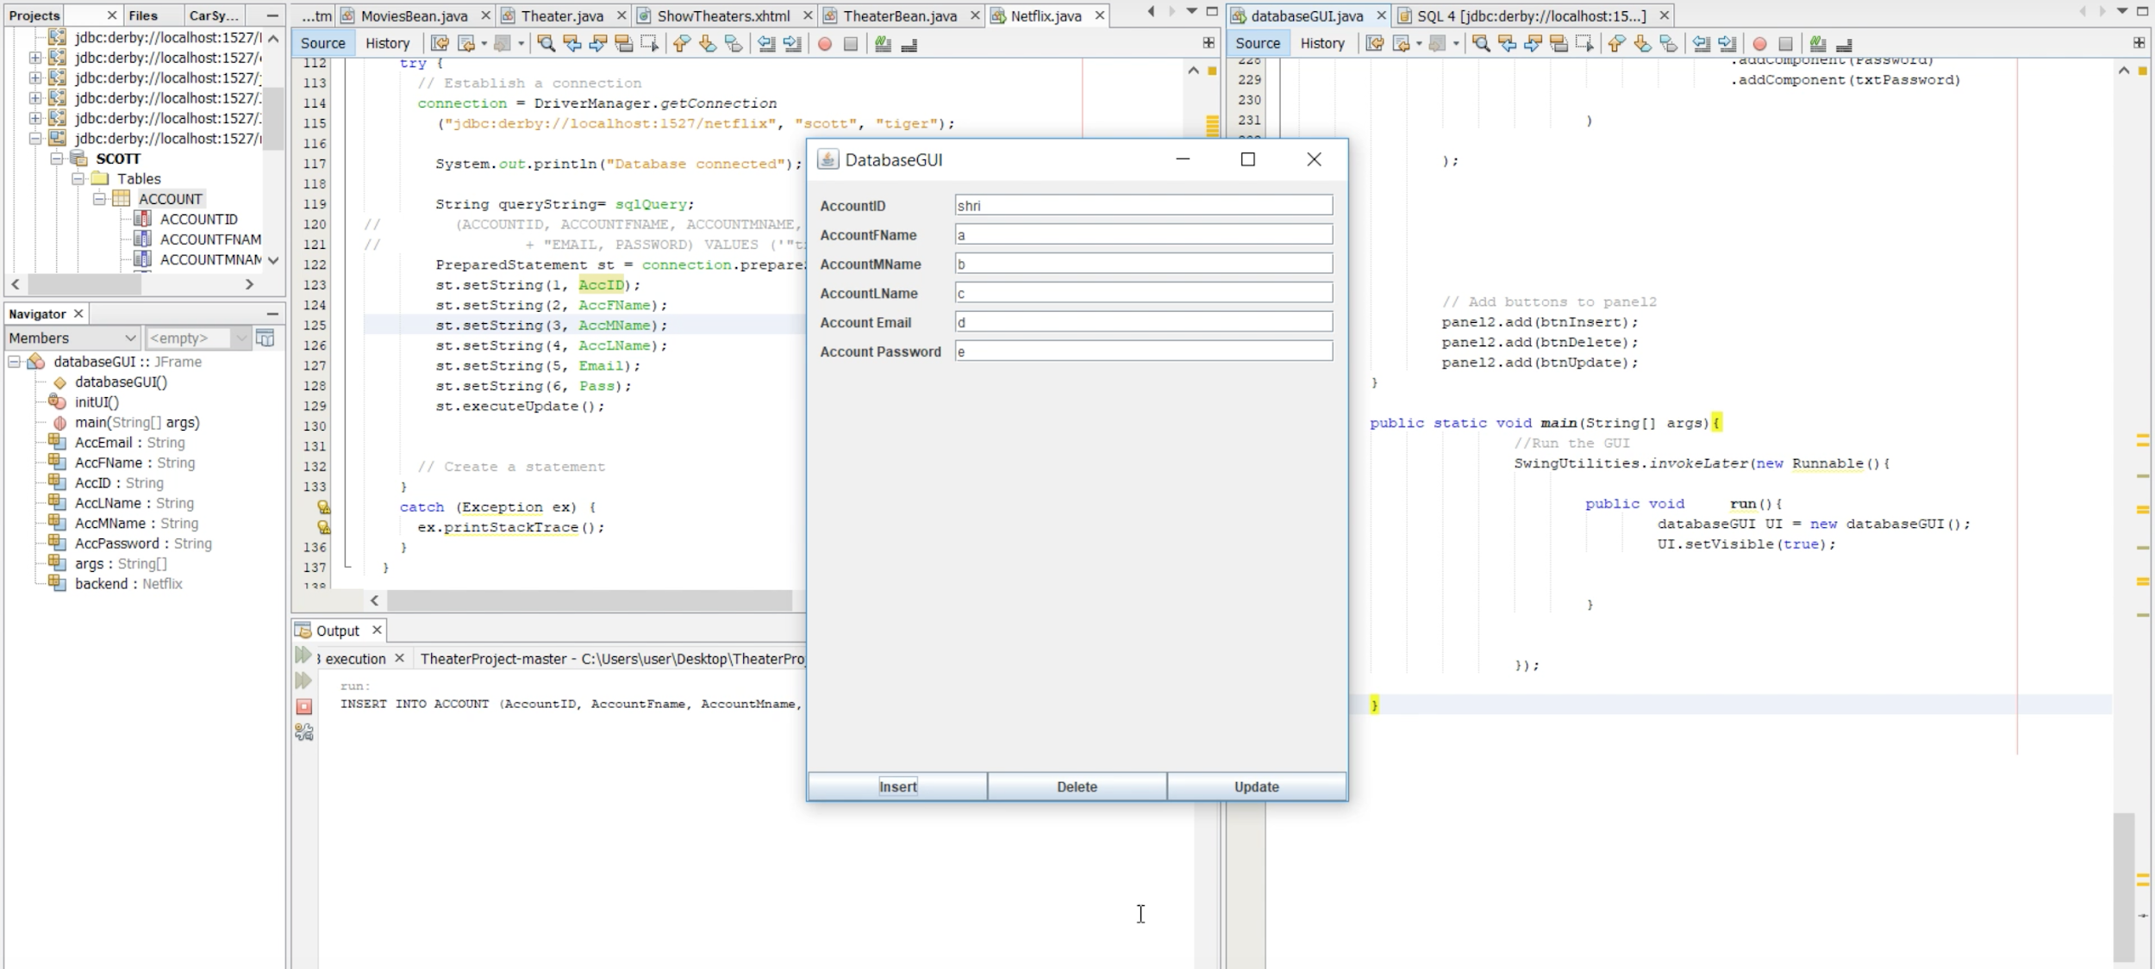

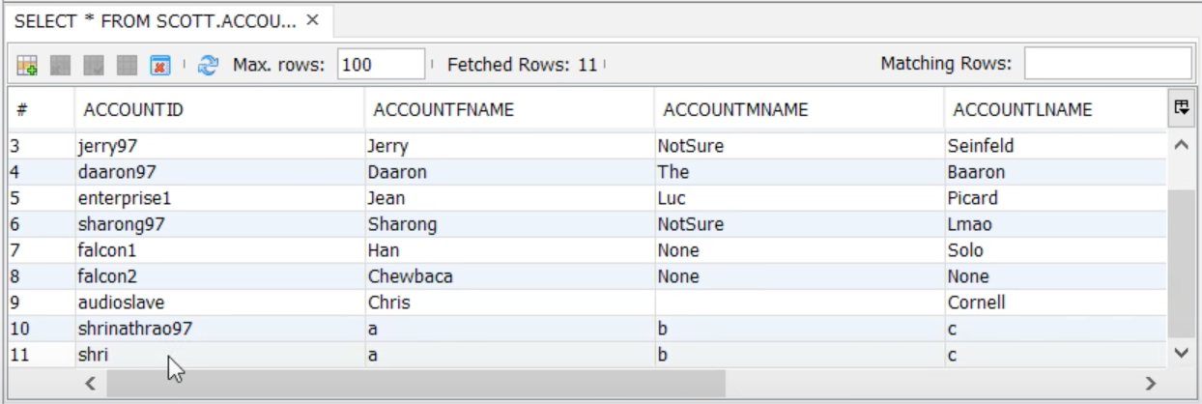

***Delete Operation on Account***

